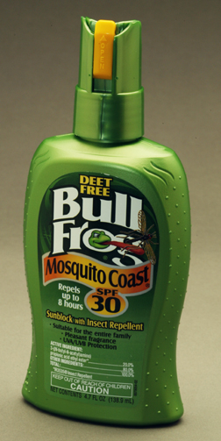
Team 6:
Aaron Greenfield
Rikki
Ashley
Buck
BullFrog
Media Planning 2011

4/29/2011
Hewlett-Packard
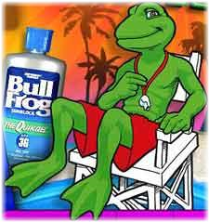
Table of Content

Section1: Executive Summary pg 3-5
Situation Analysis pg 6
SWOT Analysis pg 7-8
Section 2: Creative Brief pg 8
Strategic Message Map pg 9
Ostrow Model pg 10
Competitive Considerations pg 11-14
Competitive Media Spending pg 15
Section 3: Media Objective pg 16
Target Market pg 16-17
Media Flow Chart pg 17
Section 4: Media Delivery Metrics pg 18-19
Media Spending pg 20

Executive Summary:
The 4 P’s: Product, Price, Place, Promotion. What effect do they have on the media as relevant information about these four pillars of marketing as you can see?

Bull Frog Sun Block offers an array of sun protection products such as, Quick Gel, Marathon Mist, Mosquito Coast, Ultimate Sheer protection, Surfer Formula Gel, and Super Block. Depending on the type of product you buy from Bullfrog the prices ranges anywhere from $7 to $10. You can find Bullfrog in most retail stores as well as a majority of super markets and drug stores around the United States as well as countries overseas. With Summer coming up and the increase in outdoor activated upcoming Bullfrog is offering coupons for discounts on purchases for the upcoming summer season, deal may vary from store to store.
What is the total size of this market?

The total size of the Market for sun block is 209,373,000

What methods have been used to sell this product?

This product has been mass produced to be sold in retail, grocery and drug stores. As well as online through sites such as Amazon.com

Has advertising been used in the past? How? Which media?

This product has also been widely advertised using a variety of different mediums. Through Newspaper, TV, Magazines, Internet, Yellow Pages, and Radio.

Where is the brand in the product life cycle? If this is a new product, developing awareness may be your highest priority.

Within the product cycle Bullfrog is reaching it maturity, with competitive companies such as Coppertone and Banana Boat, Bullfrog is becoming popular. They need to raise awareness of their product and what they have to offer as a company. Being an established brand helps them , what they need to concentrate on now is getting more images out there to restore the publics interest in the company and their products.
What are the sales goals for the product?
Our current sales goals for the company are to establish an 8 percent increase, growing to 26.8 million in sales within the next two years.
Current share of market? Share goals?
Bullfrog has a current share of 5.84% of the market.
We are trying to obtain share goal of 6.31% of the market
Current awareness for brand? Awareness goals?
Our current brand loyalty is 49.4, meaning that about half of our users are a repeat user we are trying to obtain an awareness goal similar to Neutrogena trying to have a loyalty rate at 59.2
Is marketing budget available?
We are allocating 10% of sales to be directly invested into marketing. We are hoping with the growth of the company, we can further accomplish these objectives by increasing our budget to 2.68 million/
Geographic breakdown of sales?
Pacific-MKTG region annual sales of $7,518,229.74
South West sales $4,584,477.24
South East sales $5,898,798.36
West Central sales $2,777,285.70
East Central sales $1,564,668
Middle Atlantic sales $1,994,951.70
New England sales $469,400.40
- Who are all the major competitive players?
The major competitive players to Bull Frog are:
  - Coppertone
  - Neutrogena
  - Banana Boat
- What share of market do they have?
While Bull Frog comprises of 5.84% of the market share, the competition has the following:
  - Coppertone
  - Neutrogena
  - Banana Boat

- Compared with competition, is your brand unique or is it very similar to competitors?

Compared with our competition, our brand is unique in that it promotes, and symbolizes all-day waterproof sun protection with one application. In addition, Bull Frog incorporates both UVA and UVB protection with Aloe and Vitamin E moisturizers. For further pursuit of brand uniqueness, Bull Frog should utilize its’ Bull Frog character as more of a spokesman to further create brand awareness and differentiation.

- How much is the competition spending?

The competition in total is spending approximately $48 million in advertising compared to $425 million in sales.

- Which media does the competition use? Which Vehicles?

In terms of media, the competition uses:
- Print,
  - Vehicles include but not limited to ads in Airline magazines to the Wall Street Journal.
- TV,
  - Vehicles include but not limited to commercials run during Auto Racing to Young & The Restless programs.
- Cable and,
  - Vehicles include but not limited to commercials run during BBC America to MTV programs.
- Radio formats
  - Vehicles include but not limited to commercials run during Hispanic to Sports programs.

Situation Analysis:

SWOT Analysis:
Strengths:  - Unique product design  - Available growth  - Unsatisfied markets with potential  - Areas with low BDI  - Repurchase cycle | Weaknesses:  - Low brand loyalty  - Brand awareness  - Strong competition  - Low share of voice  - Product placement
Opportunities:  - Better product placement  - Better advertising  - Concern about insect carried diseases  - More defined target market  - Growing concerns over skin health | Threats:  - Growing competition  - Growing advertising spent by competitors  - Lack of dominance in brand category  - New repellant being developed  - Extremely broad market with all brands

Detailed SWOT Analysis -
Our unique product design, we believe is one of our biggest strengths as a company. Not any of our competitors have this unique blend of repellant and sunscreen. This area of potential growth is what continues to foster the idea of creating an eight percent sales growth within two years. We have selected a few markets in which we have found that there are needs are not being fully met by the competition. Many of these areas have a low brand category index, meaning that they city in which they live in does not use a specific sunscreen on a typical repurchase cycle. But with our two in one application, and not to mention the all day waterproof protection, we feel that our repurchase cycle will go up and push sales in the future.
Some opportunities in which we must seize as a company would be better product placement. We have to get out brand displayed on a highly seen area on the shelves in our target locations; if not our advertising money was not properly spent in the right areas. We feel that with more exposure to people, the better opportunities we have for an impulse buy and if satisfied, develop a brand loyalty with our sunscreen. By utilizing the outdoor advertising market we have entered a new place in which our competition has not gone before. We for once will be the dominant player in this medium, with this approach we know that with the targets must understand and know the importance of skin health, and insect repellant needs. By selecting this narrow section of the market we feel that this allows us the ability to fully engulf ourselves into this target and know everything about there spending habits, repurchasing cycle, and overall consumer habits.
Areas of particular weakness to us right now would be our low brand loyalty at a rate of 49.4% of adults being repurchase buyers. Where as Coppertone’s is at 62.9% and Neutrogena is 59.2%; we feel that if we push this area a little more, there is also an area of lost sales when dealing with a 10% difference in loyalty percentages. Brand awareness has been a large concern of ours, we feel that many people do not understand what Bullfrog is, with that being said, we must educate our consumers by showing them the helpful effects of using Bullfrog. By mixing the awareness and weak product placement in retail store, we should take these two off our weakness concerns within a short period of time. Our relative size compared to Coppertone is also another weakness of ours, we have few resources compared to this large company, and also a low share of voice in almost all the mediums of advertising.
Some growing threats to our company would be our competition; we must maintain a strong level of growth to continue to be in a situation in which we can move with our budget. We can not let them out grow us and essentially push us out of a market. We have noticed our small presence in the advertising area and must fully understand this could be a huge driving factor for business; we must stay competitive in certain areas to remain successful. A new insect repellant being developed that is of more effectiveness than our formula would also be another threat of ours. We are mixing two different markets, and are in no position to be spending against Off in the insect repellant market and Coppertone in sunscreen. We also feel that this market is becoming too broad with all the competition, this could be a major concern of ours, trying to raise awareness with all the different brands will be a major challenge.

Creative Brief:
Our brand is promising an all day waterproof protection that also guarantees protection from nuisance insect issues. “Block the burn, and the bite” is our slogan and we mean it, the dangers of UVA and UVB rays cause too much damage to the body to go unprotected, along with getting bit from mosquitoes and other hard to spot insects. We are offering this two in one application, take full advantage of its potential and live the life you want to live.
We are not offering you just sun protection, but from protection from diseases like West Nile, Yellow fever, and Malaria, where as our competitors are offering just another form of “waterproof” protection.
- Strategic message map to be inserted -

Strategic Message Map:

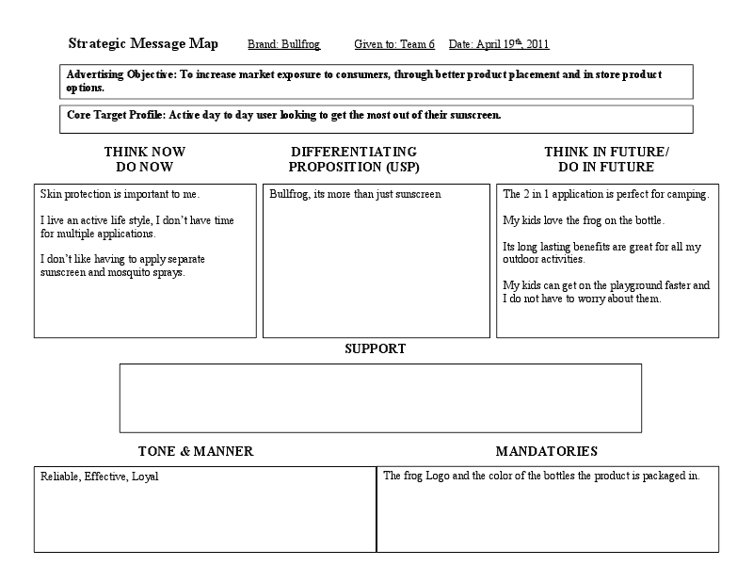

Ostrow Model:
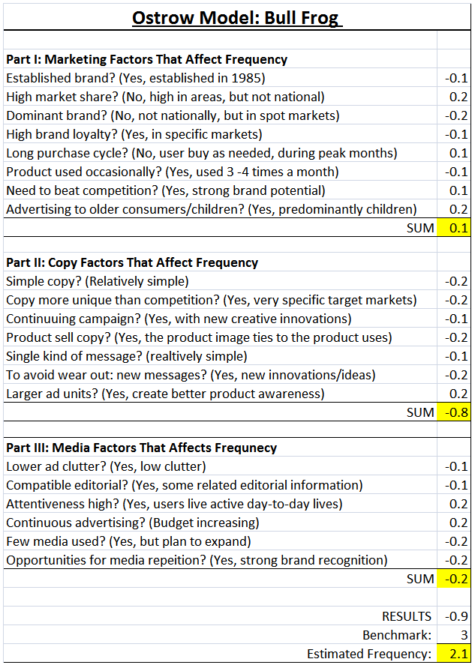

Competitive Considerations:
How is the product currently positioned?
There is a variety of different brand of Sunscreen in the same market as BullFrog each with a distinctive view on the market. Every Company offers something different to the market, giving BullFrog the ability to capitalize on their specific advantage to users by creating a new ad campaign directed to users that could benefit the most from their product.
Coppertone’s position on Sunscreen is to prevent the risks of certain types of skin cancer and reduce the aging effects of sun damage to skin. As well as a high degree of water, resistance and sweat proof so users do not have sunscreen run into their eyes. For serious users involved in sports or other activities where reapplication or water wear is a factor this gives them the edge to not have to apply Coppertone as often as other brands in the same market. Their slogan is “Tan – Don’t Burn” implying that they offer a greater range of protection with longer lasting features for all types of users.
Banana Boat is a little different they take a more direct approach to protecting users from the sun with a patent AvoTriplex system of protection allowing not just a enhanced UVB and UVA protection but for longer periods of time with less applications. Banana Boat’s slogan is multipurpose “We’ve Got You Covered” implying that no matter the situation your skin care my need they have the answer.
Hawaiian Tropic is a brand geared more towards the user’s range of options; while they offer a wider range of different sunscreens they also have more options in the area of luxury. Meaning they have more products with different scents and functions for skin care as well as a wide verity of sun care products for caring for consumers with the after effects of over exposure to the sun without sufficient protection. Hawaiian Tropics current slogan is “The Indulgence you want with the skin protection you need” giving users the sense that they can get the proper skin care and luxury skin care products.
BullFrog gives user two functions in one, while offering sun protection there sunscreen also offers the ability to repel insects. This positions BullFrog more in the specific category of users who want complete protection from the elements. This is a specific group of users which is both an advantage and a disadvantage, as certain markets are more susceptible for BullFrog while others may not need the mosquito repellent functions as much and turn to alternative brands. As with their position, BullFrog’s slogan is “Block the Burn, and the Bite”.
Which media are currently being used by this brand?
Bullfrog is currently using Newspapers, TV, Magazines, Internet, Radio, and Yellow Pages.
Is this product high or low involvement? If involvement is medium to high-prospect is willing to invest time to gain knowledge about the product, and has considerable interest in the consequence of the purchase. Media should be considered that allow enough copy to provide details, e.g., magazines, internet or newspapers. If involvement is low-product purchased on impulse or with very little time investment-radio, TV or outdoor may be effective media choices.
The product involvement is about medium, consumers consider the contents of the product, they search for specific SPF protection; Bullfrog offers all day waterproof protection, which gives them a broader market of users, now they also have an insect repellant added to their sunscreens. The ultimate users of the product want to obtain a certain level of knowledge about the product to make sure that they are getting the right protection they want.
Link for Bullfrog commercial
http://vimeo.com/8093941
Planogram of sunscreen
http://www.commissaries.com/business/planogram/pdf_planograms/SunCare2DPromotionsMarch112DSeptember1129_id767.pdf
Make a list of benefits and specific qualities of your product, including psychological benefits. For example, in the case of the Demae Sushi bar, benefits might include: Fresh seafood, low fat, low calorie, fresh vegetables, and no artificial flavors. Guilt-free indulgence is a clear psychological benefit.

- BULLFROG products deliver both UVA and UVB protection.
- SPF levels available, 30, 36 and 45, the formulas themselves have different physical characteristics. The different forms include an anhydrous gel, a lotion, a solid stick, a quick-drying gel and a vanishing-color lotion for kids.
- BULLFROG okay to use under makeup.
- Guaranteed by the manufacturer to deliver the product’s benefits until the expiration date. The product may still deliver the stated benefits well beyond the expiration date but there is no guarantee.
- Helps prevent sunburn. Higher SPF gives more sunburn protection. Retains SPF after 80 minutes of activity in the water or perspiring.
- BULLFROG sunscreen does not use PABA. As such, cases including skin rash and loss of appetite were minimized.
- Some products are made in conjunction with insect repellant.
- Offers peace of mind that sun exposure is limited when BullFrog is applied accordingly.

How do users feel about the brand? Attitudes? Lifestyles?
There is a range of feelings toward the brand which include attitudes and lifestyles. Listed below are a couple of reviews of BULLFROG which provide athletic usage reviews on the product from amazon.com.
- 5.0 out of 5 stars Best Sunblock!
Bull Frog Sunblock spf 45 is the best we have ever used. My children are very fair, blond and blue-eyed. Nothing has worked on them as well Bull Frog. I highly recommend it to anyone who is very prone to burning.

Published on September 16, 2007 by S. Harrison

- Lita Lepie
This review is from: Bull Frog Sunblock Superblock Lotion, SPF 45, 5-Ounce Bottles (Pack of 2) (Health and Beauty)
I read the other reviews and believed them. My mistake. After forty minutes of rollerblading the stuff was in my eyes. As it was after forty minutes of kettlebell exercises on my roof.
I have had melanoma. I am a personal trainer. So called previous waterproof, sweatproof products did exactly the same thing. It is NOT advised that one rollerblade with eyes closed, yet that happens briefly. The stuff burns the eyes.
So this review is really relevant for people who are active and athletic. These so-called sweat proof products work for about forty minutes and then fail. So I've devised some other solutions. Currently I am covering my forehead with fabric treated with sun protection and applying the product beneath the eyes. [I always wear large lensed photo chromatic goggleish glasses which protect the eyes from sun damage.] Another way to go would be, I think, skydiving or ski goggles that actually seal the eye area from moisture [I think - I haven't tried them yet], or, perhaps, swimming goggles. I have the latter, but they aren't that comfortable.

- Great for scuba, April 28, 2008
K. Earley "Xspect" (Jackson, MS) - See all my reviews
(REAL NAME)
This review is from: Bull Frog Sunblock Superblock Lotion, SPF 45, 5-Ounce Bottles (Pack of 2) (Health and Beauty)
Great product. I use this for scuba trips. Works as advertise. Just a little thick going on.
How is the product/service used? Consumed? When?

This product is sun block, used to protect a person’s skin from sunburn. The
consumer applies the lotion or spray to the skin directly exposed to the
sun.

What percent of budget should be consumed for national media? Spot media?

A 5% budget should be considered for national media, whereas 10% of the
budget should be allocated to spot media.

Competitive Media Spending:

Media Objective:
Although Bullfrog has a high user loyalty, its total users and total sales are less than its competitors. This is due to the range of media their competitors like Coppertone use. With a wider outreach to consumers, competitors are able to capitalize on a larger market of users and gain sales. What we play to do is strategically place Bullfrog in markets where they will be needed and where current threats are less dense to consumers. This will allow Bullfrog to gain users through adding new forms of media that is strategically placed during the year to capitalize on the season for sun block users in our category. By creating more media in areas where the need for sunscreen is already present we don’t have to teach the public about why to use sunscreen. We simply have to show them that they should use our product over competitors due to its added advantage of mosquito repellant and long lasting single application.

Target Market:
After researching different markets of users for Bullfrog our group is going to target two markets. Markets: Parents and three children in households.
Parents
We choose parents because in households with children they make the purchases for supplies that are needed for activates and day to day living. With being parents with children it is also, more difficult to find free time, so any products that save them time is essential. With Bullfrog, they get a two in one application of both sun block and mosquito repellent without having to apply two different products. Bullfrog is also long lasting requiring fewer applications over the time of use, allowing both the parents and the children more time for other activities. This would be a great benefit for parents on a day-to-day basis, allowing them more opportunities for activities with their children.
Despite the fact that parents have a lower index than 3 children households and considerably lower index to brand such as Coppertone, they still have the purchase power of households over children. We feel it is important to target the parents as well to reinforce the purchase power of the household. While the children play a part in the parent decisions they still do not make the final purchase decisions. This is also important because parents index number to comparative brands like Coppertone are higher because it is more widely known in most areas with good sources of media coverage. We want to let parents know that Bullfrog is just as good and has mosquito repellant, which is an added benefit without the added application. To do this we want to emphasize the frog as an icon for children as well as a metaphor for Bullfrog sun block and its effectiveness. Depicting the frog in the sun, showing that even as a cold-blooded retile he is still protected enough to be exposed to sun light as well as having the ability to keep insects away.
Three Children in Households
Households with three children are at the higher probability to purchase Bullfrog due to its 2 in 1 benefits and long lasting features. Parents of households with 3 children need products like Bullfrog to make sure both decrease the time it takes to apply both sun block and mosquito repellant as well as protect their children from the sun when outdoors. Bullfrog is also unique to kids with their ability to market there “frog” logo that is kid friendly helping them associate a image to the product. Through ads children can relate the frog to sun protection and in time of purchase help parents make the distinction using the symbol of the little green forg protected from the sun and keeping the bugs away.

Media Flow Chart:

Media Delivery Metrics:
Outdoor
Cities | Population 25-34 | % of Observers | # Reached
Phoenix, AZ | 602,500 | 13% | 78,325
Denver, CO | 540,000 | 13% | 70,200
San Diego, CA | 442,600 | 13% | 57,538
Portland, OR | 396,700 | 13% | 51,571
Charlotte, NC | 367,700 | 13% | 47,801
Raleigh, NC | 376,200 | 13% | 48,906
Nashville, TN | 327,300 | 13% | 42,549
San Antonio, TX | 284,900 | 13% | 37,037
Norfolk, VA | 245,600 | 13% | 31,928
Memphis, TN | 242,200 | 13% | 31,486
Total Reached |  |  | 497,341
Radio
Cities | Population 25-34 | % of Listeners | # Reached
Phoenix, AZ | 602,500 | 10% | 60,250
Denver, CO | 540,000 | 10% | 54,000
San Diego, CA | 442,600 | 10% | 44,260
Portland, OR | 396,700 | 10% | 39,670
Charlotte, NC | 367,700 | 10% | 36,770
Raleigh, NC | 376,200 | 10% | 37,620
Nashville, TN | 327,300 | 10% | 32,730
San Antonio, TX | 284,900 | 10% | 28,490
Norfolk, VA | 245,600 | 10% | 24,560
Memphis, TN | 242,200 | 10% | 24,220
Total Reached |  |  | 382,570
Magazines
Cities | Population 25- 34 | % of Readership | # Reached
Phoenix, AZ | 602,500 | 8% | 48,200
Denver, CO | 540,000 | 8% | 43,200
San Diego, CA | 442,600 | 8% | 35,408
Portland, OR | 396,700 | 8% | 31,736
Charlotte, NC | 367,700 | 8% | 29,416
Raleigh, NC | 376,200 | 8% | 30,096
Nashville, TN | 327,300 | 8% | 26,184
San Antonio, TX | 284,900 | 8% | 22,792
Norfolk, VA | 245,600 | 8% | 19,648
Memphis, TN | 242,200 | 8% | 19,376
Total Reached |  |  | 306,056

We are choose these different areas because we feel that they are outdoor cities and have a lot of different activities that take place outdoors. With a lot of population being outside with their families they would benefit most from using bull frog. We chose these different types of media because we believe this is how our product will be seen and benefit most from using these different types of media.

GRPS= 302000/100= 3020

Bullfrog Media Spending:

